<click F1 for into>
Attn:

Quote No.
PO No.
Fee:
Date:

[Please select the transaction type(s)]
Software Relocation Software Return/Exchange Authorization Code/License Deletion

Dear Customer: Please verify and complete any missing information, sign, and send this form back to the Sales Office identified above.

Current Site No. |  | New Site No. | <entry required-click F1 for info> | Contact Name:
Customer Name: |  | Customer Name: |  | E-mail Address:
Site Address: |  | Site Address: |  | Phone Number:

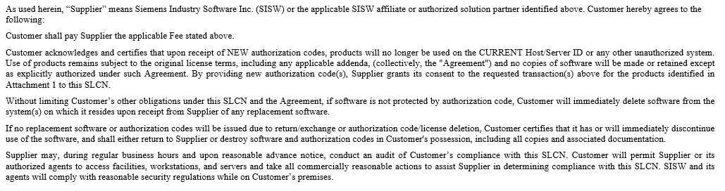
By signing, or in the case of electronic submission by typing your name below, an authorized representative of Customer accepts and agrees to the terms of this SLCN:
Customer Representative: Title: Date:

Quote#
PO#
Fee:
Date:
New Site No: | <click F1 for info>
<click F1 for into>

ItemID | Part No. | Software Description | Qty | Version | CURRENT  ServerID | CURRENT  HostID | NEW  ServerID | NEW  HostID

Comments:

